# Instructions Page

Please complete the following half sized landing page in only **html/css**. Try to format the page as closely as possible to the template (second page). Please send back page and code.

Specifics about the page:

* Title in H1
* A bolded h2 “Jeep Models” heading
* Row of three Jeep models with title names in H3 as “New Jeep Model Type”
* Each image will click to its corresponding page below

For Jeep Grand Cherokee, link image to <https://www.jeep.com/grand-cherokee.html> For Jeep Compass link image to <https://www.jeep.com/compass.html>

For Jeep Wrangler link image to <https://www.jeep.com/wrangler.html>

* A paragraph below the row of models that will have “Jeep incentives and offers” underlined and linked to

<https://www.jeep.com/vehicle-selector.incentives.html?app=incentives>

* And lastly, a row of three buttons (color/size of your choice) with each given name/linkage.

Build Your Vehicle links to <https://www.jeep.com/vehicle-selector.bmo.html>

Search Our Inventory links to <https://www.jeep.com/vehicle-selector.sni.html?app=sni> Jeep Life links to <https://www.jeep.com/jeep-life.html>

Images to use for Landing Page

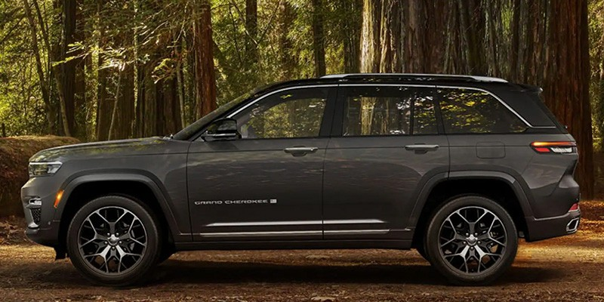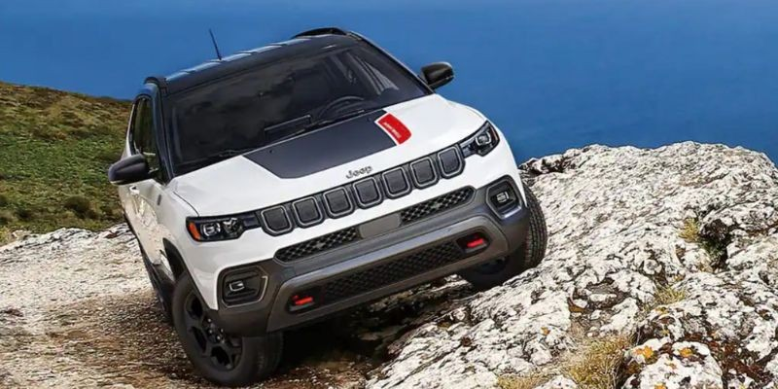

Research New Models Below

# Jeep Models

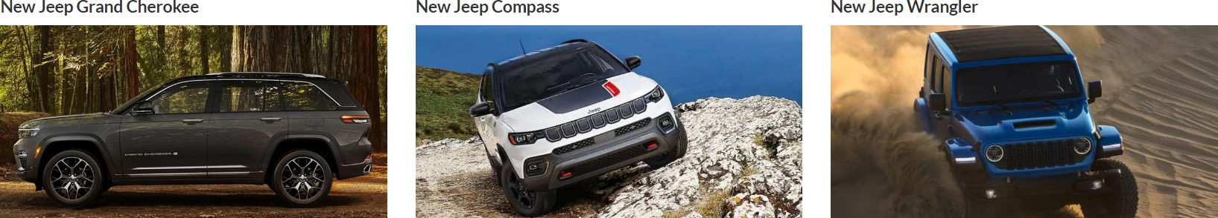

Please feel free to check out our Jeep incentives and offers or for more information on Jeep, click on one of the following buttons below.

{Build Your Vehicle} {Search Our Inventory} {Jeep Life}